Upgrading from NADA 3 to NADA 4

Before you upgrade, please make sure you have made a backup of your NADA site and database. The upgrade makes changes to your NADA 3 database and you won’t be able to undo these changes if upgrade fails.

Step 1: Backup Database
Make a backup of your NADA 3 database and save it to a safe location.

Step 2: Backup data files
The data files (DDI, external resources, reports, questionnaires, data) are stored in the DATAFILES folder under your NADA3 site. Even though the upgrade to NADA4 does not make any changes to your data files folder, we still recommend you make a backup of your data files.

Step 3: Setup NADA 4
Make a folder for NADA 4 on your server and extract the NADA4 installation files.

Step 4: NADA4 database and other configurations

4.1 Configure database
Go to your NADA 4 installation folder and edit the [nada4]/application/config/database.php file and put your NADA3 database connection settings. The settings will look something like this:
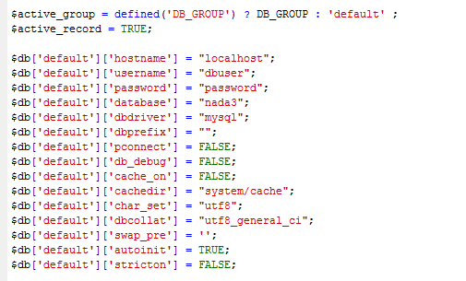
Please make sure you enter the information exactly as you have in the NADA 3 database settings file.

4.2 Enable maintenance mode
To enable the upgrade script to work, you must enable the maintenance mode by editing the [nada4]/application/config/config.php file.
- Open the config.php file in notepad
- Look for the setting “maintenance_mode” and change the value to 1
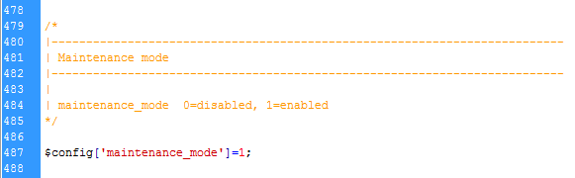
- Save the file.

Step 5: Folder permissions
Make sure the following folders have been granted WRITE access for NADA4:
[nada4]/cache
[nada4]/logs
[nada4]/datafiles
[nada4]/files
[nada4]/imports

Step 6: Running the upgrade script
- Open your web browser (e.g. Internet explorer or Chrome) and enter the URL http://[your-nada-4-site]/index.php/nada4_upgrade. (see screenshot below)
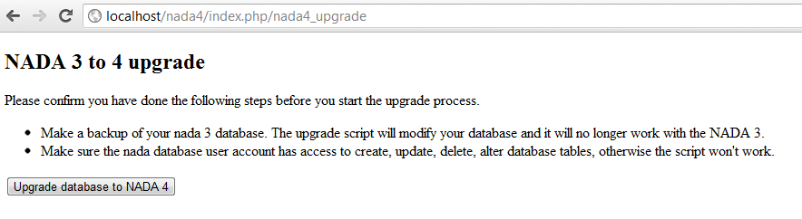
Warning: This step makes changes to your nada 3 database that are not undo-able so make sure you do make a database backup before this step.

- Click on the “Upgrade database to NADA 4” button and wait for the page to reload. The output of the page will look something like below:
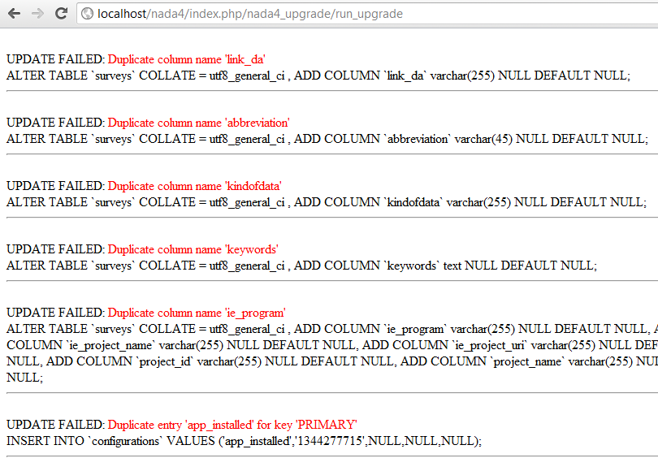
The script will print number of messages about failed updates. It does not mean the script failed to upgrade, it is just some of the updates didn’t work on your version of NADA 3. The different versions of NADA have different number of fields in the database and the upgrade script tries to fix the missing fields for all these different versions of NADA and if you already have that field then it reports it as an error.
You can ignore the error messages that include the wording “Duplicate column name” or “Duplicate entry”. If you see any other error messages then you will have to fix them by using a database client such as PHPMYADMIN or MySQL Workbench.
Example of an error message: See below. This is a how an error message is printed. The first line prints the error returned by the database in red color indicating the reason for failure. Anything starting from the second line is the actual SQL that was executed and failed. If you like to fix your database manually using a SQL Client, you should copy everything starting from line 2 and use it via SQL client to run on your database to make the changes.

Step 7: Verify database upgrade
Open the NADA catalog page by going to http://[your-nada4-site]/index.php/catalog page and verify that you see all your studies from NADA 3 listed.

Step 8: Link your data files to NADA 4
We need to configure in NADA 4 where your data files are located. There are two options depending on what works best for you.
Option 1: Copy the datafiles folder from NADA 3 to NADA 4. This works best if you have fewer studies and datafiles folder size is small enough to be moved easily from one location to another.
Option 2: If it is not possible to easily move the datafiles folder from NADA 3 to NADA 4, you can tell NADA 4 the location of the datafiles without moving the files. Here are the steps:
- Use your NADA 3 login credentials to login to your NADA 4 site. Go the “Settings” menu, click on “Settings” sub-menu .
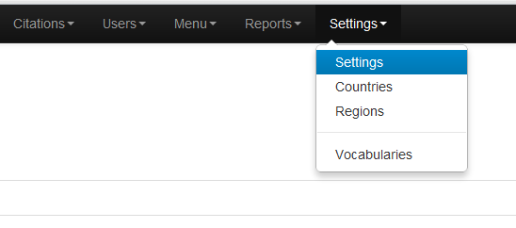
- Under Site configurations, expand the “Survey catalog settings”. For NADA 4
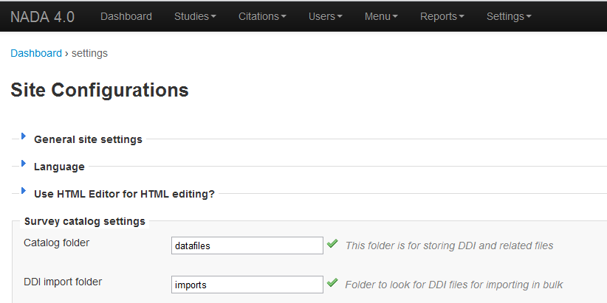

- For the setting “Catalog folder”, enter the relative or full path to where you datafiles folder is located. For example, if you nada3 datafiles is located on c:/nada3/datafiles, you can enter that path here.
- Save the configurations by clicking on the update button. If you don’t see any errors thrown then you have successfully updated the folder path.

Step 9: Verify database and datafiles folder setting changes
- Check the user administration page from site administration to make sure you see all users from your nada3 site.
- Check the “Data Catalog” page and view the studies by clicking on the study title to make sure you can view the study info pages
- Check the site menus are same as what you had in NADA 3.

Step 10: Refresh DDI
In NADA 4, we store much more information in the database from the DDI than the NADA 3. The refresh DDI is a feature in NADA that updates the database with metadata from the DDI without you re-uploading your DDIs.
To update the metadata for all studies in your catalog:
- Open the URL in your browser: http://[your-nada-4-site]/index.php/admin/catalog/batch_refresh
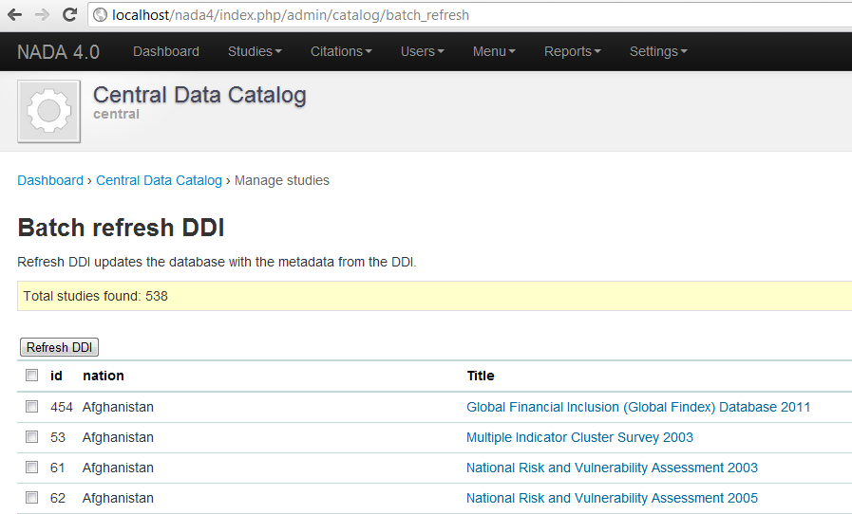
- Select all studies
- Click on the “Refresh DDI” button
- Done!

Step 10: Post upgrade steps
After you have completed the upgrade, you should:
- Disable maintenance mode: edit the [application/config/config.php] and change the value for “maintenance_mode” to 0.
- Remove the “install” folder
- Remove the file: application/controllers/nada4_upgrade.php

